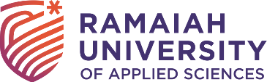 FHMCT, MSRUAS is NBA Accredited

Faculty of Hospitality Management and Catering Technology (FHMCT), M.S.Ramaiah University of Applied Sciences received the National Board of Accreditation (NBA) for the Bachelor of Hotel Management (BHM) Program. FHMCT is among the two (currently accredited) institutions for the BHM program.

This accreditation promotes international standards for technical education. NBA is a quality assurance and improvement process to critically check the institutions fulfilling the norms and standards regulated by the regulator. It is a recognition that the institution fulfills the required technical education standards and excellence.
All the stakeholders are benefitted from this accreditation. The major benefits to the students are:
- Accredited institution and program offers international quality education and recognition.
- Employers value degrees from an accredited program.
- Enhances employability of graduates.
- Provides the institution with a separate identity in the national and international market.
- The institution is committed to excellence and continuous quality improvement.
- Helps the Institution in securing necessary funds.
- The institution is eligible for the recognition of the programs by other signatories of the Washington Accord.
- Facilitates transnational recognition of degrees and mobility of graduates and professionals.
- Assurance of the good standing of an Institution to government departments and other interested bodies.
- Contributes to the social and economic development of the country by producing high-quality technical manpower.

Students, faculty members, staff, and employers associated with an NBA-accredited institution get multifold recognition in the professional world.

